A Minor Project Proposal on

Online Travel Marketplace
Submitted in partial fulfillment of the requirements for the degree of
Bachelor of Engineering in Software Engineering at Pokhara University

By
Aayush Parajuli
Prakriya Parajuli
Sworup Khadka


Department of Research and Development
GANDAKI COLLEGE OF ENGINEERING AND SCIENCE
Lamachaur, Kaski, Nepal
(October, 2023)
A Minor Project Proposal on

Online Travel Marketplace

Submitted in partial fulfillment of the requirements for the degree of Bachelor of Engineering in Software Engineering at Pokhara University.

By
Aayush Parajuli
Prakriya Parajuli
Sworup Khadka
Supervisor
Dr. Bidur Devkota

Department of Research and Development
GANDAKI COLLEGE OF ENGINEERING AND SCIENCE
Lamachaur, Kaski, Nepal
(October 2023)

APPROVAL CERTIFICATE
This project entitled "Online Travel Marketplace" prepared and submitted by "Aayush Parajuli, Prakriya Parajuli & Sworup Khadka" under the supervision of "teacher name" in partial fulfillment of the requirements for the Degree of Bachelor of Engineering in Software Engineering has been examined and is recommended for approval and acceptance.

Date of Evaluation: October 12, 2023

……………………………………
Dr. Bidur Devkota
(Project Supervisor)

…………………………………
Er. Rajendra Bahadur Thapa
Project Head
Research Management Committee
Gandaki College of Engineering and Science

ABSTRACT
The "Online Travel Marketplace" project will be a groundbreaking endeavor in the realm of travel and tourism, aimed at enhancing the experiences of travelers exploring the beautiful landscapes and rich cultural heritage of Nepal. The Online Travel Marketplace project aims to enhance the travel experiences of explorers visiting Nepal by providing an intuitive web-based platform that simplifies and streamlines the booking of travel experiences. This platform will collaborate with local tour operators to curate authentic and unforgettable adventures

TABLE OF CONTENTS
APPROVAL CERTIFICATE iii
ABSTRACT iv
TABLE OF CONTENTS v
Chapter 1 1
INTRODUCTION 1
1.1 Background 1
1.2 Problem Statement 1
1.3 Objectives 2
1.4 Implications 2
Chapter 2 3
LITERATURE REVIEW 3
Chapter 3 5
TOOLS AND METHODOLOGY 5
3.1 Required Tools 5
3.2 Methodology 5
3.3 UML Diagrams 6
3.3.1 Use Case Diagram 6
3.3.2 Wireframe Diagram 8
Chapter 4 10
PROJECT TIMELINE 10

LIST OF FIGURES
FIGURE 3.4: SEQUENCE DIAGRAM FOR CREATING ACCOUNT……………12 FIGURE 3.5: SEQUENCE DIAGRAM FOR NEW REGISTRATION FORM……13 FIGURE 4.1: GANTT CHART……………………………………………………..15 FIGURE 5.1: WIREFRAME OF THE ACCOUNT CREATION PAGE…………...16 FIGURE 5.2: WIREFRAME OF REGISTRATION PAGE………………………...17 FIGURE 5.3: WIREFRAME OF HOME PAGE……………………………………18

Chapter 1

INTRODUCTION

1.1 Background
Online Travel Marketplace aims to level the playing field in the online travel booking space in Nepal by democratizing access to travel booking systems for smaller and mid-sized businesses. It also seeks to simplify the travel experience for travellers, streamlining the process and reducing the stress associated with planning their journeys.
Online Travel Marketplace is a specialized online platform meticulously crafted to tackle the challenges encountered by both travel businesses and travelers when navigating Nepal's diverse landscapes. This platform provides travelers with a seamless and user-friendly interface, empowering them to discover and book an extensive array of travel experiences customized to Nepal's distinctive attractions.

1.2 Problem Statement
Small & Medium sized travel businesses, despite their unique insights and local expertise, find themselves at a significant disadvantage due to financial constraints, unable to compete on a level playing field. Furthermore, the travel experience for travelers in Nepal is fraught with complexities and uncertainties. Transparency issues cast a shadow over the booking process, and the absence of local travel businesses in the digital sphere limits travelers' options and experiences. The result is a landscape where both businesses and travelers face significant challenges.

1.3 Objectives
The main objective is to establish a robust online travel marketplace as a web application to empower smaller and medium-sized travel businesses in Nepal.
The specific objectives of this project are as follows:
- Make online travel booking accessible to smaller and medium-sized travel businesses in Nepal.
- Create a user-friendly platform that simplifies the process of planning and booking travel experiences in Nepal.
- Establish a level playing field for travel businesses of all sizes by providing equal opportunities and access within the marketplace.
- Advocate for responsible tourism practices to preserve Nepal's natural and cultural heritage while promoting economic growth.

1.4 Implications
The Online Travel Marketplace project carries profound implications for Nepal's travel industry and its stakeholders. By democratizing the online travel booking space, it opens doors for local businesses, particularly small and medium-sized enterprises to compete on a level playing field, fostering their growth. This empowerment extends to travelers who will gain access to a curated selection of travel experiences, offering them more fulfilling and personalized journeys. The project also addresses long-standing issues of transparency and trust within Nepal's travel industry. By eliminating opacity in the booking process, it seeks to build trust between travelers and service providers

Chapter 2

LITERATURE REVIEW
In the dynamic realm of the travel industry, we derive valuable insights from influential online travel booking platforms such as Booking.com, MakeMyTrip, and TrekkingDude. These industry giants offer a plethora of travel products and services, constituting a foundation for Online Travel Marketplace' venture. However, it's crucial to recognize their strengths and the areas where innovation is imperative.

Booking.com is a global stalwart established in 1996, commands an extensive portfolio of travel products, encompassing over 28 million accommodations worldwide. Nonetheless, Booking.com's registration and listing procedures may pose challenges for smaller Nepali travel businesses. This platform occasionally struggles to cater to the unique needs and preferences of travelers exploring Nepal.

MakeMyTrip is India's leading online travel booking platform since 2000, offers a comprehensive array of services, from flights and hotels to tours and car rentals. Similarly, smaller travel businesses in Nepal encounter hurdles during the registration and listing process on MakeMyTrip. Adapting to Nepal's distinctive local travel landscape can present ongoing challenges.

TrekkingDude, based in Kathmandu, Nepal, since 2015, specializes in trekking and tour packages, providing invaluable local expertise. It ensures a user-friendly interface, competitive pricing, and flexible payment options. However, it's essential to acknowledge that TrekkingDude does not operate as an open marketplace, primarily offering its trekking and tour services. While appealing to trekking enthusiasts, this approach may not fully address the diverse spectrum of travel experiences sought by travelers in Nepal.

The reviewed models, Booking.com and MakeMyTrip, falter in providing the distinct and localized experiences that travelers in Nepal desire, leaving a void in the market. Additionally, they pose significant barriers for small and medium-sized Nepalese travel businesses. TrekkingDude's lack of an open marketplace further restricts the range of available travel experiences. In contrast, Online Travel Marketplace emerges as a transformative solution to bridge these gaps and meet the unique demands of Nepal's travelers and businesses.

Chapter 3

TOOLS AND METHODOLOGY

3.1 Required Tools
To develop the application, we will require various tools essential for the project. Our project will use the following tools:
- PHP: For Server side scripting.
- JavaScript: For Client side scripting.
- HTML and CSS: For Frontend design.
- Draw.io: For diagramming software.
- MYSQL database: For managing system databases.
- Google Docs: For writing proposals and reports.
- Figma: For UI/UX design.

3.2 Methodology
Every software development methodology approach acts as a basis for applying specific frameworks to develop and maintain software. Several software development approaches have been used since the origin of information technology. The online travel marketplace web application system implements the Waterfall model. It is compatible with the size of our project and suited for the available time frame.

3.3 UML Diagrams

3.3.1 Use Case Diagram

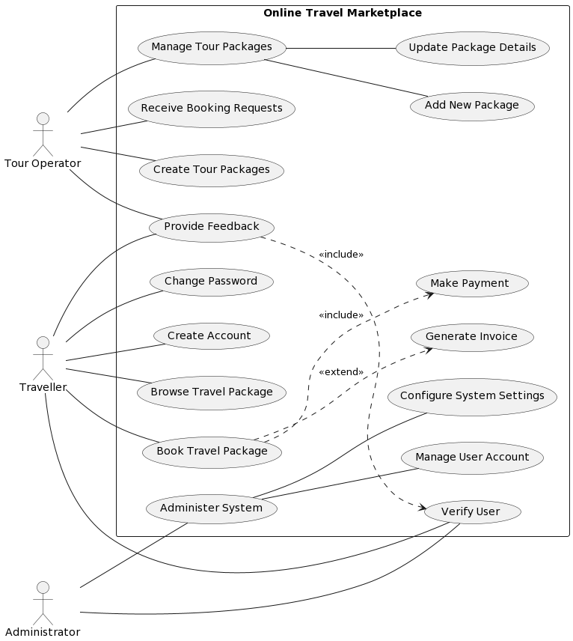
A use case diagram is a way of visualizing the requirements and functionalities of a system. It shows the actors (users or roles) and the use cases (actions or goals) they can perform in the system. In this diagram, the system is an online travel marketplace that allows tour operators, travelers, and administrators to interact with each other. The diagram shows what each actor can do in the system, such as managing, browsing, booking, and providing feedback on travel packages, as well as administering user accounts and system settings. The diagram also shows the relationships between the use cases, such as inclusion, extension, and generalization.

3.3.2 Wireframe Diagram
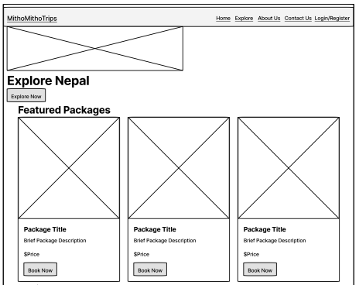
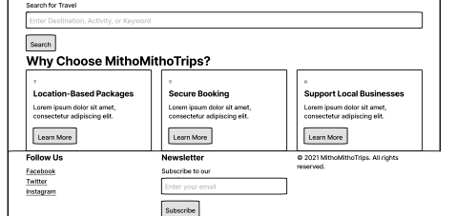
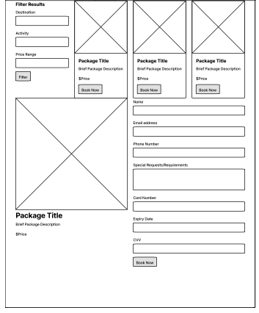

Chapter 4

PROJECT TIMELINE
The project events are scheduled as follows:

 | Task name | Duration | Start | End
1 | Project identification | 8 days | Oct 14, 2023 | Oct 21 2023
2 | Requirement Analysis | 10 days | Oct 21, 2023 | Oct 31 2023
3 | System Design | 22 days | Oct 31, 2023 | Nov 21 2023
4 | Coding | 30 days | Nov 21, 2023 | Dec 21 2023
5 | Testing | 30 days | Dec 21, 2023 | Jan 20, 2024
6 | Implementation | 20 days | Jan 20, 2024 | Feb 9, 2024
7 | Documentation | 120 days | Oct 14, 2023 | Feb 11, 2024

